PO Box 3683, Manuka, ACT 2603
capitallakes@gmail.com www.rowingact.org.au/clrc/

PARA-ROWING COME & TRY DAY

Sunday 31st August 2014, 9:00am-12:00pm

Located in the Kingston Foreshore – Causeway Drive

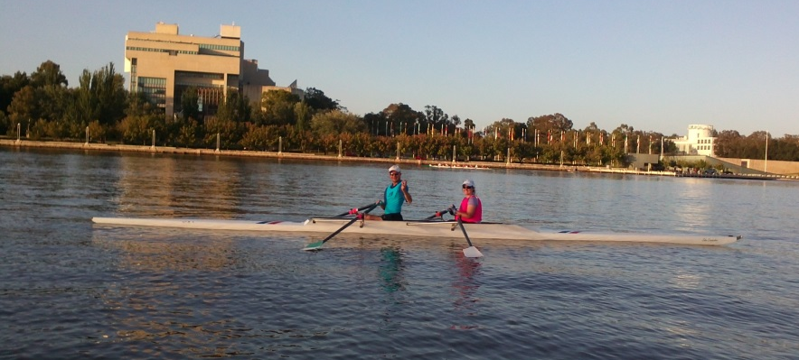
Para-Rowers Rob Oakley and Mikaela Dingley enjoying Lake Burley Griffin
Capital Lakes Rowing Club is expanding its para-rowing program in partnership with Rowing ACT and Rowing Australia. We provide coaches and facilities to support para-rowing for people with a wide range of ages and physical or intellectual impairments. Our emphasis is on active participation in a friendly and inclusive club environment.
The Come and Try Day will give individuals an opportunity to learn about our para-rowing program, check out the para-rowing facilities available, and have a go at rowing!
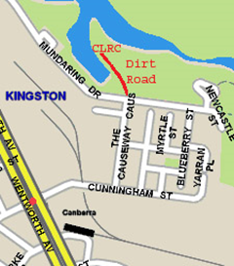
Those who wish to take up rowing should then attend the Learn-to-Row course of 5 sessions on Sunday mornings during September and October.
If you are unable to attend the Come & Try Day but are interested in learning about CLRC Para-rowing, then please get in touch so we can make special arrangements.
For more information and RSVP, contact Charlie Barton:
T:02-6273 7477, M: 0406 377 599, cebarton@gmail.com.

CLRC thanks ACT Sport & Recreation Services, the Australian Paralympic Committee, and the Coca Cola Foundation of Australia for their support.

