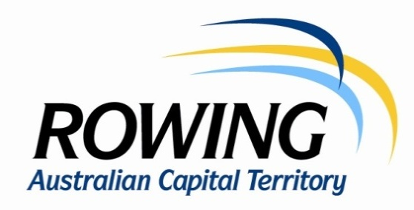
MINUTES OF BOARD MEETING
YMCA Sailing Club, Yarralumla Bay
Wednesday at 6.30pm 21 June 2017
Present: D. Bagnall (Chair), P. Marshall, J. Williams, P. Davoren, R. Curtin, N. Hunter, J. O’Brien (Executive Officer).

Apologies: V. McMahon, C. Bowyer, A Chinn.

Minutes: Minutes of the meeting of 17 May 2017 were read and confirmed.

Matters Arising: High Performance – Approaches to ensuring transparency in HP program were discussed. Meeting agreed that RACT needs to know the basis for appointing and releasing athletes and that written reports from the program are required to provide this information.

President’s Report: President reported on the interviews for the Pathways Coach in which R. Domaschenz was the outstanding candidate. N. Garrett will be visiting all clubs and giving coaching seminars tailored to the needs of each club. Expressions of interest have been requested in a Level 3 coaching coaching course. There have been several inquiries. WTT - discussion of perennial issue of crews seeking changes to the course to suit less experienced crews. Meeting agreed that the course, especially the location of the first turning buoy, is a known factor and clubs should decide before entering crews whether they are capable of safely participating. Yarralumla Bay - consultation has commenced on a CGS proposal to site two pontoons on the west side of the Bay. CRC has made CGS and NCA aware of difficulties this would present for crews making parallel landings on this bank. High Performance – the agreement with RA has been finalised. Only outstanding issue is to demonstrate to RA that sufficient HP athletes can be recruited to the program.

Executive Officer’s Report: Standard Membership Forms - a standard set of Terms and Conditions have been developed that each individual registering with a RA State association must agree to. National Sponsorship Plan – Agreed plan requires states not pursue their own sponsorships until the national sponsors are settled (to avoid clashes between sponsors in the same areas). Mandatory Coaching Accreditation – States are all moving to mandatory accreditation. Standard Volunteer Agreement – these will be put in place to address issues such as claims for payment by by “volunteers”. Kings Cup Centenary 2019 – RA has asked for ideas from each state for how they could be involved in the celebrations. Larger states are holding functions which would not be practicable in the ACT. One option for the ACT is celebration built around an expanded Disher Cup program in 2019. R. Curtain to explore options for a function. Changes to National Insurer - We are now covered by Aon policies since the existing insurance expired on 31 May. Policies are guaranteed to be at the same or better level of cover at no extra cost. As a part of the National Sponsorship Plan we received a share of RA’s revenue from the deal. Winter Time Trials - after two WTTs entries are up on last year (276 in 2017 v 231 in 2016). Riggers – Sporting Schools program -
Clubs were chosen that are the closest to the suburbs where it is thought that the program can be delivered. Currently includes only indoor rowing, on-water rowing will be dependent on more ASC funding. Regatta Subcommittee – First meeting for 2016-17 on Thursday 29 June.

Safety: An incident report has been submitted in respect of a collision on 16 June 2017 between a Defence 4x and a BMRC 2-. It seems clear that the Defence boat had strayed well onto the course into the path of the pair which was following a correct course. It was fortunate that the incident seems not to have resulted in serious injury.

Strategic Plan Update: Meeting agreed that members should participate in a review of the Strategic Plan in conjunction with the Annual Stakeholder Forum on Wednesday 11 October 2017.

Board Succession: Members were asked to canvass interest in their clubs in joining the Board bearing in mind the need to retain and if possible increase the level of female representation.

Communications Strategy: Board was asked to provide further comments on the draft circulated by the Executive Officer. Meeting agreed that the school rower demographic should be targeted to facilitate the school to club transition. A further edition will be put out after comments.

Boat Race Official Recruitment: Options identified by EO were discussed. Paying BROs does not have broad support. Junior BRO Program seems worthwhile exploring. Potential BROs should be made aware of the opportunities for national accreditation.

Lake Users Group: June meeting was held at the Wetlands Information Centre. Items of interest included the boardwalk in Central Basin and recognition by planners that wave absorbing Lake walls are desirable in any new projects. Traffic flows around Orana Bay and Yarralumla Bay are being considered with the likely outcome being one way traffic past the boatsheds. This part of Alexandrina Drive looks like becoming Alexandrina Place making location of addresses – importantly for emergency services - much easier.

Meeting Closed: 7.45 pm
…………………………
Chairman
19/7/17

