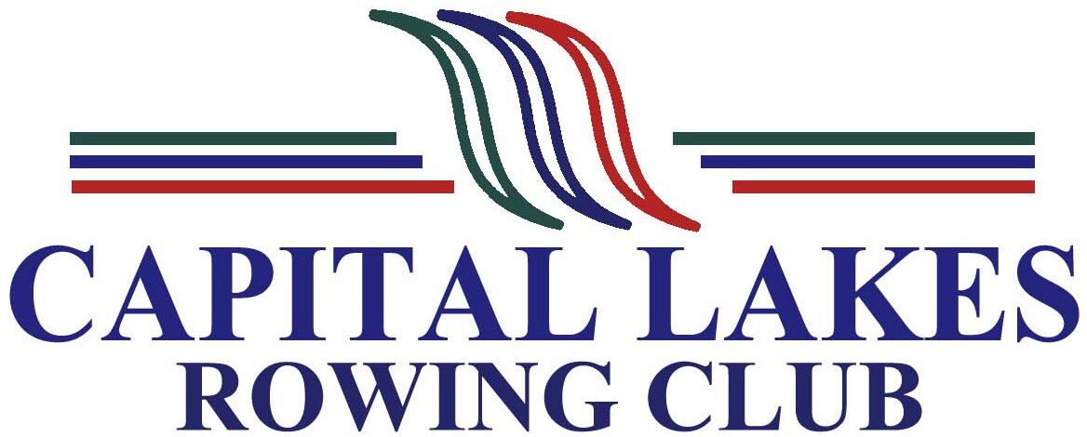

2020 School Holiday Rowing Program
Registration Form

Please complete and return to capitallakes@gmail.com

Name of Student
Address
Telephone
Email
Date of Birth |  |  | Female  Male
School |  | Year at School:
Rowing Experience
Program  (please choose which program time you would like to attend) | 8.30am – 10.30am  11.00am – 1.00pm

EMERGENCY CONTACT DETAILS – all students must provide parent/guardian details.

Name/s | Telephone | Email

DECLARATION

- I am a competent swimmer, able to swim 100 metres in light clothing, and will prove so if asked.
- I will advise CLRC of any injury or illness that may affect my ability to participate in rowing activities for the duration of the program.
- I authorise CLRC to take reasonable action on my behalf (including the incurring of expenses) in connection with any injury or illness that I may incur while engaged in Learn to Row activities.
- I do / no not agree to my photograph being used on the CLRC website.

Signature:

Applicant _______________________ Parent/Guardian: ______________________

Date:_____________________

As mentioned previously, we have limited places on the School Holiday Rowing Program and registrations will be accepted on a first-come basis.

Once your application has been processed, you will be issued with an invoice. Program fees are to be paid in full to secure your place on the program, and prior to commencement of the program.

Once payment has been received you will be emailed acceptance of your place on the program.

Official Use

Registration received ___/___/___ Invoice Issued ___/___/___

Payment Received ___/___/___ Program Acceptance emailed ___/___/___

