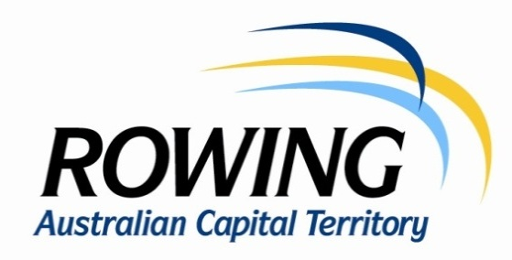
MINUTES OF BOARD MEETING
YMCA Sailing Club, Yarralumla Bay
Wednesday at 6.30pm 17 May 2017
Present: J. Williams (Chair), V. McMahon, P. Davoren, C. Bowyer, P. Marshall, A. Chinn, J. O’Brien (Executive Officer).

Apologies: D. Bagnall, R. Curtin, N. Hunter.

Minutes: Minutes of the meeting of 19 April 2017 were read and confirmed.

Matters Arising: High Performance - meeting noted that a bridging contract has been concluded with R. Domaschenz pending permanent filling of the position of Pathways Coach and that the recruitment process has been fast tracked. Meeting considered that Board needs to more involved in oversight of the High-Performance Program (HPP) in line with the Board’s new responsibilities for staff and past oversights including unilateral decisions affecting member clubs.

The Board expects to be involved in any further consideration of a third HPP staff member, especially if RACT is expected to contribute funds. As a general principle, the HPP should not operate to the detriment of the RACT budget. A further requirement of RACT is that HPP participants should be members of a RACT club. Reporting arrangements for the HPP were discussed. It was agreed that HPP should be an item early in the agenda to consider a monthly written report by the Head Coach who will be asked to brief the Board in person quarterly. A. Chinn and P. Davoren were asked to provide any further comments before the next Board meeting.

Boat Driver Recruitment - Board agreed that an advertisement be put in the Canberra Times seeking expressions of interest from licensed boat drivers. Board noted the heavy workload taken on by G. Northam as head of the BROs and the need to identify a potential understudy. Replacement Umpires Boat – In view of uncertainty about the likely disposition of the RA coaching boats, V. McMahon will make inquiries about what boats are available. It was agreed that a replacement is needed for the “Daisy Boat” before the start of the 2017-18 season. Presentation Event – Everyone agreed that this was an enjoyable occasion and thanked J. Williams for planning it. BRO Function – There has been positive feedback on this event. EO’s efforts were acknowledged.

Director of Finance Report: V. McMahon has met with the Auditor to discuss the draft 2016-17 accounts. He has no issues with the accounts. Director of Finance will be away from Canberra from mid-June to mid-August. Club census returns were discussed. Noted that affiliation receipts for 2016-17 were close to those for 2015-16. DOF was commended for his efforts in pursuing reliable membership statistics. Noted that participants in the Winter Time Trials need to be registered.
Executive Officer Report: Rowing Australia’s Riggers Program - RA has identified a club to participate in a pilot program aimed at increasing participation of secondary school students in rowing. The Board agreed that it was unusual for RA to have made this decision without reference to RACT. EO to seek details from RA. National Sponsorship Plan – RA is proposing to appoint Aon as its insurance broker for four years. This will see sponsorship money from Aon going to State bodies – RACTs share will be $2,867.70 (ex GST).
Regatta Secretary Report: A. Chinn reported that a letter will be sent to T. Trobe initiating the 2017 Regatta Subcommittee review of regatta dates and programs and related matters and providing directions from the Board. S. Croot and O. Nix have agreed to review the grade scores for ACT going into Rowing Manager.
Safety: Board agreed that a safety briefing be held at the start of the 2017-18 season that will include HPP and RA ITC representatives. N. Hunter is following up on placement of the “Big Buoy” in West Lake that has proved a hazard to rowers.

Strategic Plan: Board noted the deficiencies of the strategic plan 2015-20 due largely to changed circumstances and priorities and agreed that all directors submit comments and detailed drafting suggestions for early consideration by the Board.

Communications Strategy: Communications Survey provided valuable commentary on current communications and proposed improvements. Facebook posts have been well received. EO will incorporate comments on the survey in an action sheet for consideration by the Board. N. Latimer has offered to assist with communications projects.
In response to comments in the Survey, the Board agreed to communicate directly with members through Rowing Manager contact details. Rowing Manager will be used to broadcast some key messages, announcing events, notices of RACT General Meetings and consultative forums and safety warnings. This messaging will not replace the normal information management carried out by Member Clubs. This will not cover schools who have their own requirements and procedures.

Other Business: Board agreed that Annual General Meeting will be held on Wednesday 23 August. Next meeting will consider succession planning.

Meeting Closed: 8.21 pm
…………………………
Chairman
21/6/17

